Report on the Trip as Part of the Task "Promotional Campaign to Attract International Doctoral Candidates and Supervisors" under the Project "Actions towards the Internationalization of the Doctoral School of the University of Life Sciences in Lublin (ISDULSL)" - dated December 15-18, 2025, to Nitra (Slovakia), NAWA STER programme.
Project Beneficiaries:
- Alina Kowalczyk-Juśko, Ph.D., D.Sc., Eng., Assoc. Prof. – Sub-Department of Ecological Engineering, Department of Environmental Engineering,
- Milan Koszel, Ph.D., D.Sc., Eng., Assoc. Prof. – Subdepartment of Quality Management and Production Processes, Department of Machine Operation and Production Processes Management
- Ewelina Knosala, MS.c., specialist- administrative staff member of the Doctoral School Office at the University of Life Sciences in Lublin,
- Małgorzata Szwed, MS.c Eng., 3rd-year PhD student at the Doctoral School of ULSL (Department of Machine Operation and Production Processes Management),
- Anastasiya Ramankevich, , MS.c Eng., 3rd-year PhD student at the Doctoral School of ULSL (Institute of Biological Basis of Animal Production),
- Patrycja Cichosz, , MS.c Eng., 2nd-year PhD student at the Doctoral School of ULSL (Department of Vegetable and Herb Crops),
- Joanna Kowalik, MS.c., 1st-year PhD student at the Doctoral School of ULSL (Department of Preclinical Veterinary Sciences).
Role of Beneficiaries in the Doctoral School at ULSL:
- Two research and teaching staff members,
- One administrative Staff member of the Doctoral School of ULSL,
- Two PhD students in the disciplines of Agriculture and horticulture,
- 1 PhD student in the discipline of Animal science and fisheries,
- 1 PhD student in the discipline of Veterinary medicine;
Host Institution:
Slovak University of Agriculture in Nitra, Nitra, Slovakia.
Visit Schedule:
December 15-18, 2025

Report on the Visit:
First day of the visit:
- Travel to the destination. Departure from the UPL building, Akademicka Street, arrival at the hotel in Nitra, Slovakia.
Second day of the visit:
- The meeting was opened by the Vice-Rector for Communication and Practice, Pavol Findura, who, together with representatives of the Department of Machines and Production Biosystems of the Slovak University of Agriculture, presented the university. Representatives of ULSL academic staff and PhD students from the ULSL Doctoral School delivered a promotional lecture covering the university’s research and teaching offer, including opportunities for student exchange at various education levels. During the meeting with staff, they were introduced to the doctoral study program at the ULSL Doctoral School and recruitment possibilities for scientific supervisors among university employees.
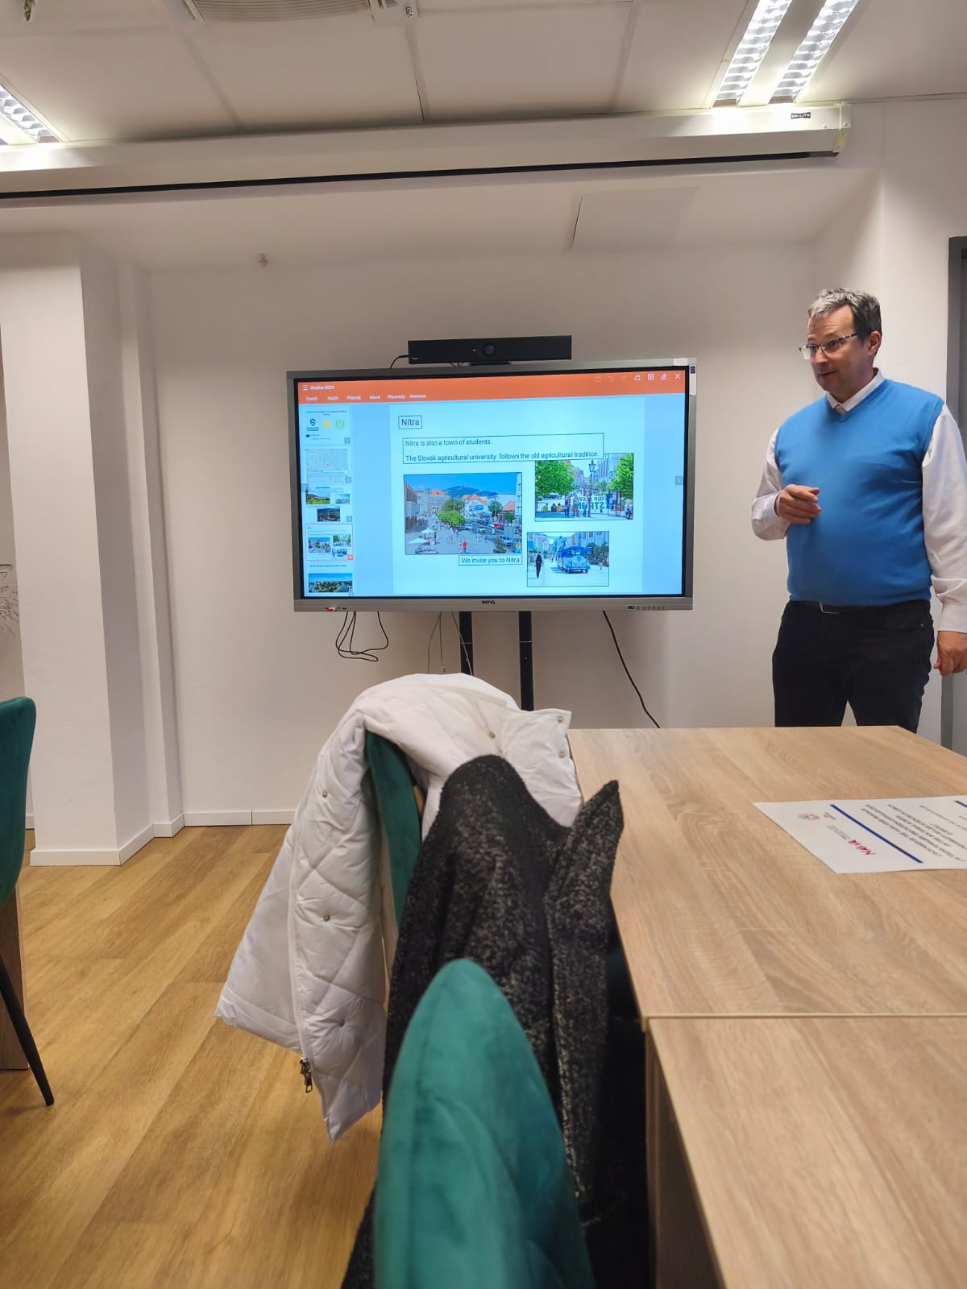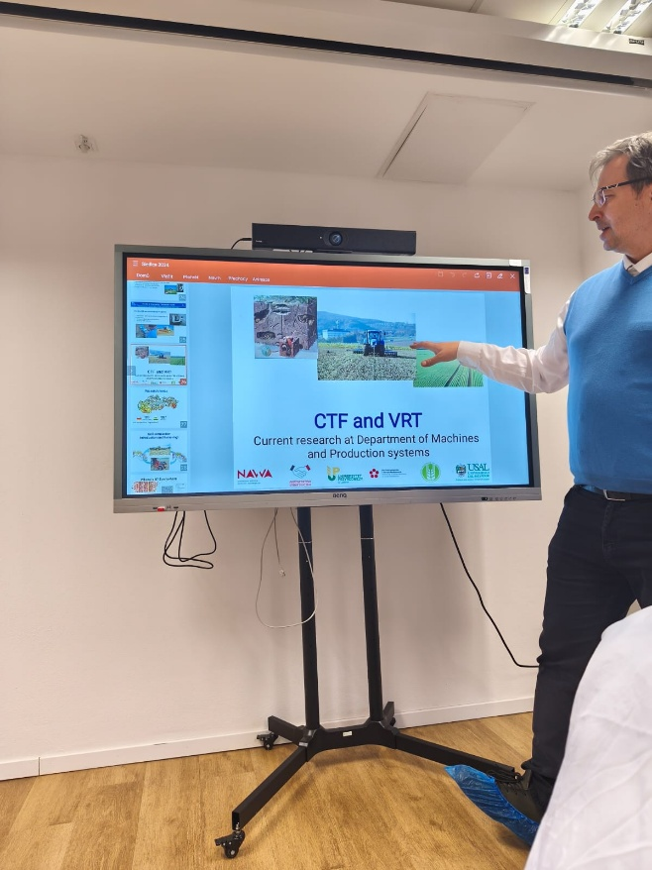
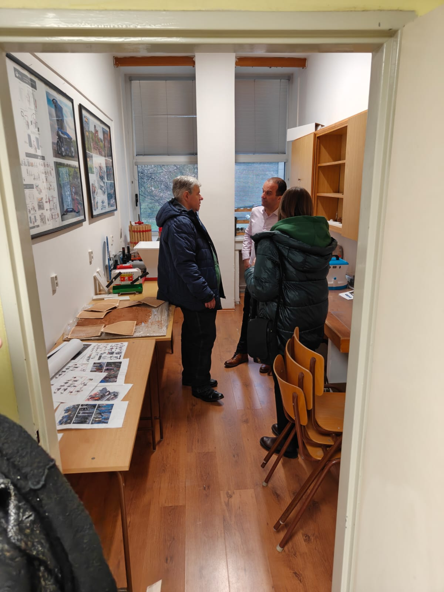
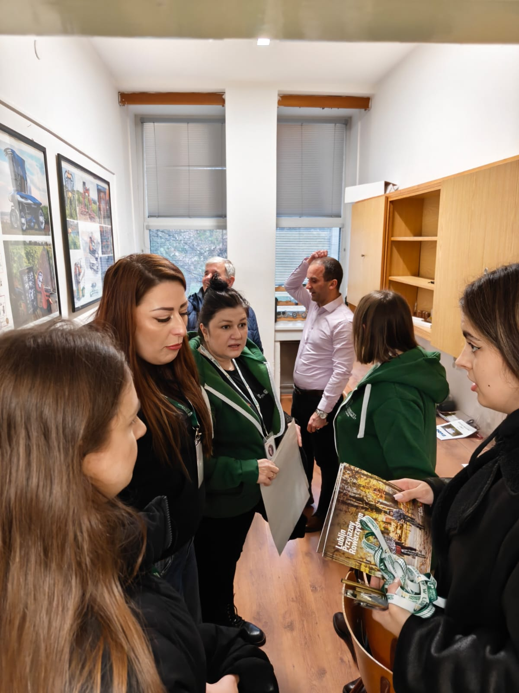
- During the meeting with students and PhD candidates of the Slovak University of Agriculture, the offer of completing parts of first- and second-cycle studies under the Erasmus+ program was presented, as well as the promotion of the Doctoral School of the University of Life Sciences in Lublin.

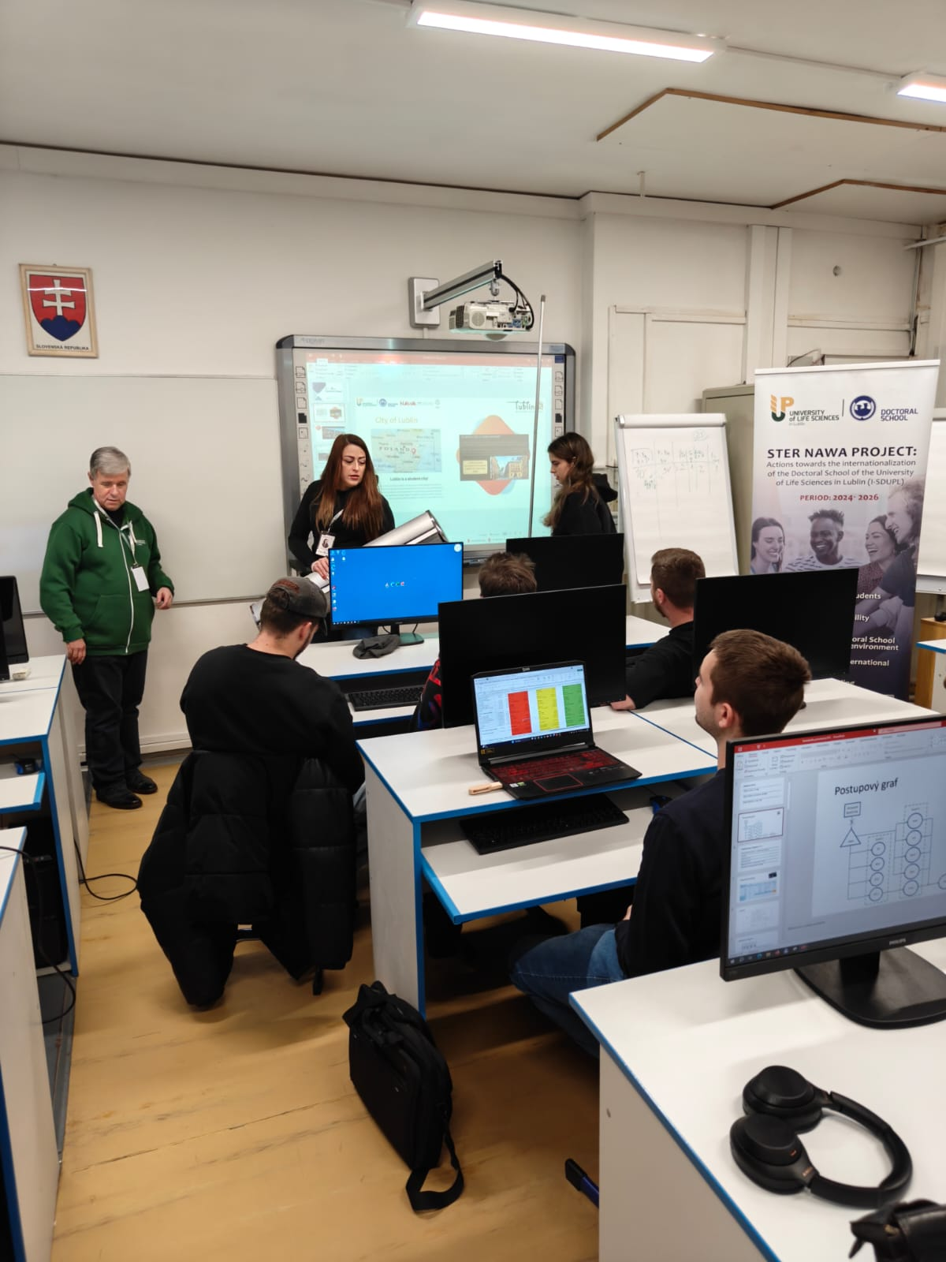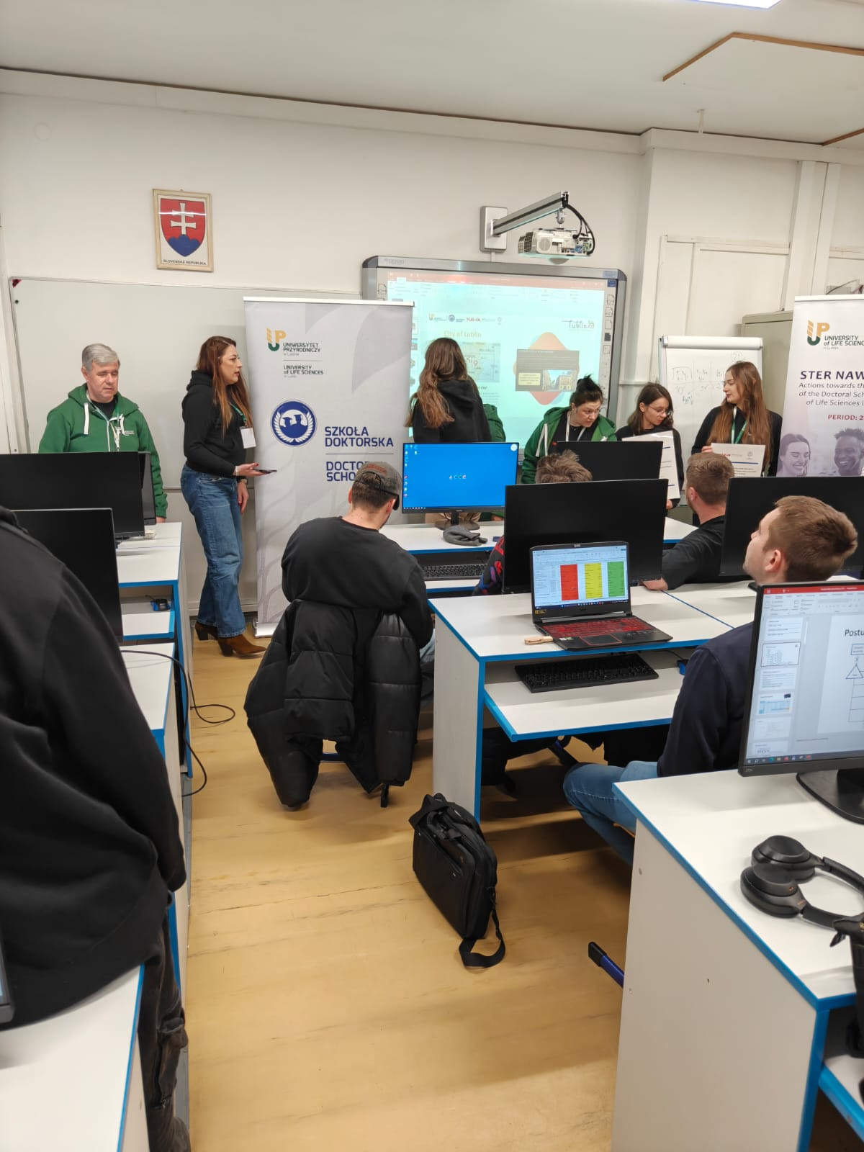

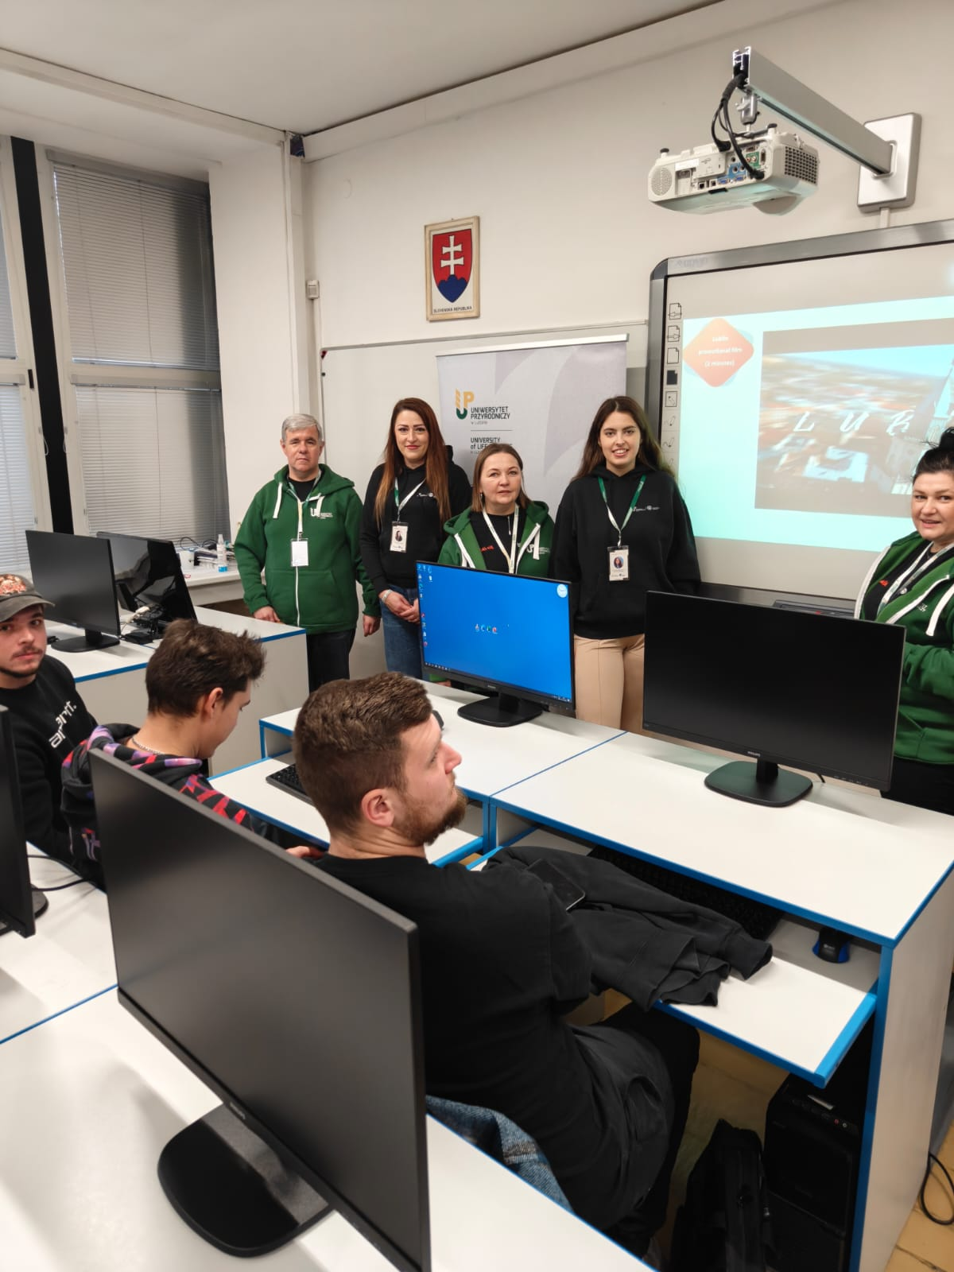
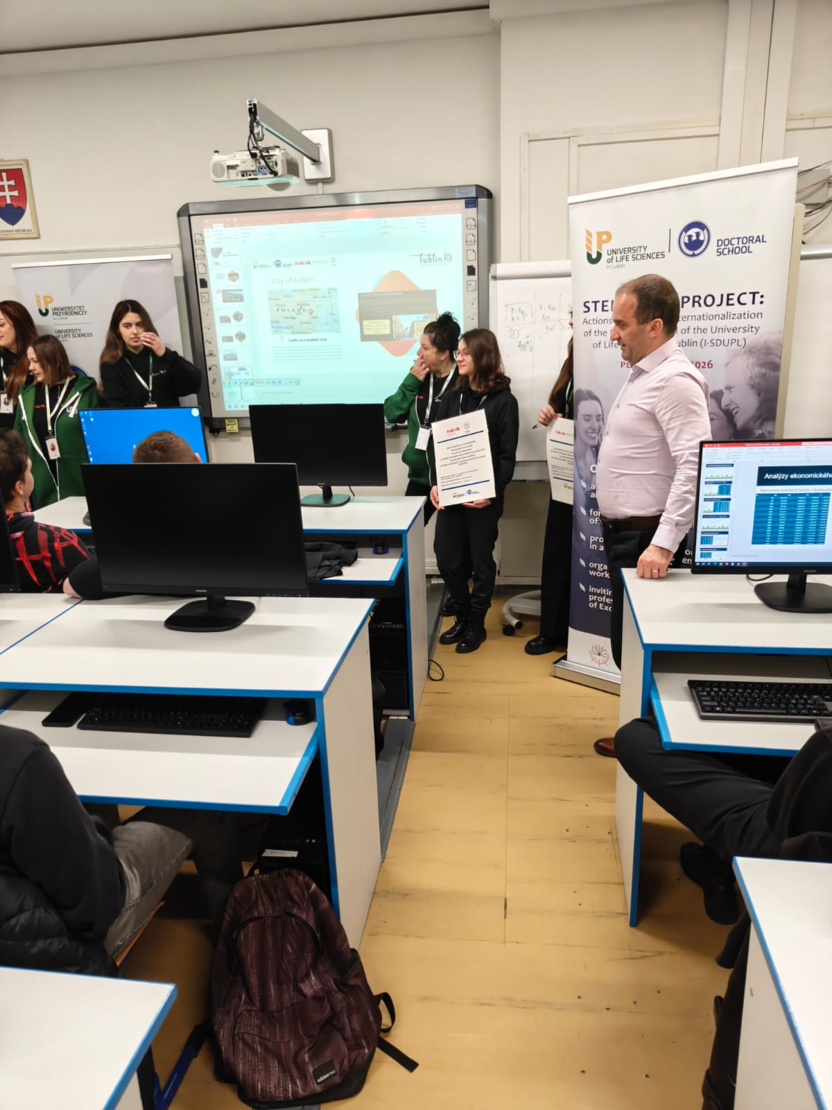

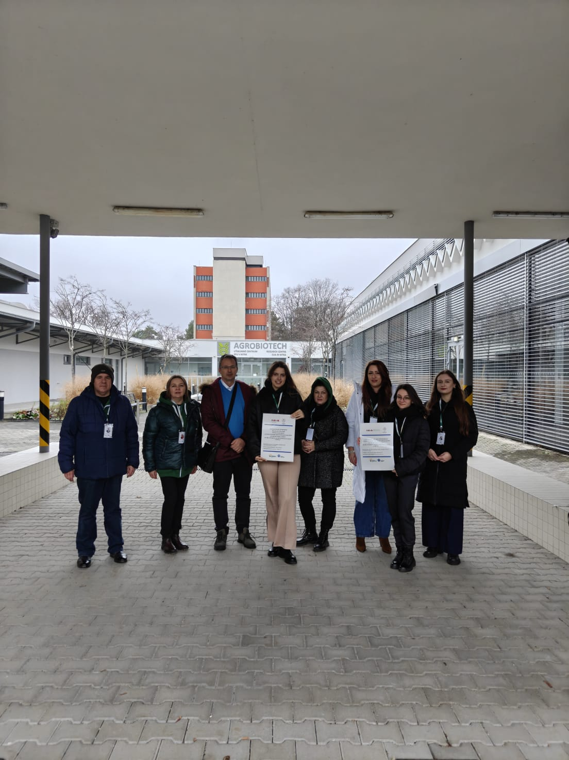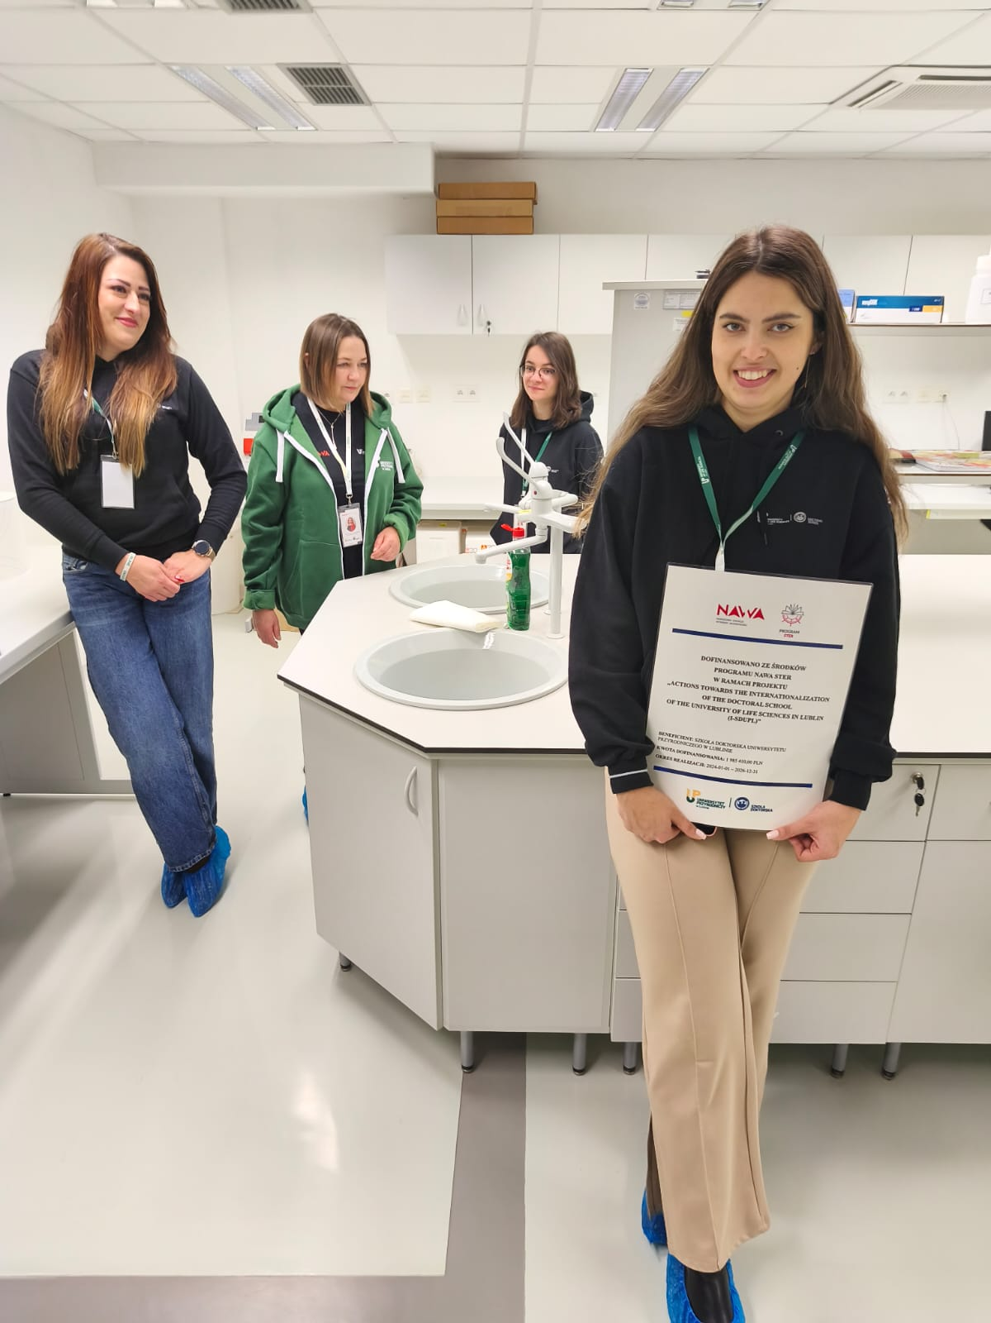
The third day of the visit:
- Participants were introduced to the research capabilities of the AgroBioTech Research Center of the State University in Nitra. The AgroBioTech Research Center is a specialized facility conducting focused innovative research in various fields aimed at introducing new methods and procedures in research, especially applied research, with the primary goal of implementing research results. The center is equipped with state-of-the-art research infrastructure enabling high-level research applicable in practice, closely related to key needs of priority sectors such as agrobiology, technology of processing agricultural and agri-food products, biotechnology, genetic technology, agroecology, bioenergy, and bioeconomy. The mission of AgroBioTech is to integrate key research activities to achieve a synergistic effect in utilizing and increasing the research potential of the Slovak University of Agriculture.
- The role of the AgroBioTech Research Center is to conduct research, particularly with direct social and economic impact, support innovation, develop modern technologies, and provide advisory services. The establishment of the AgroBioTech Research Center has become a stimulus for conducting top-quality scientific research and development activities, supported by excellent equipment in an environment conducive to interdisciplinarity and teamwork.
- The AgroBioTech Research Center is an open workplace. Its infrastructure, including both equipment and personnel, can be used by research and development entities and for cooperation in conducting research with UPL employees.
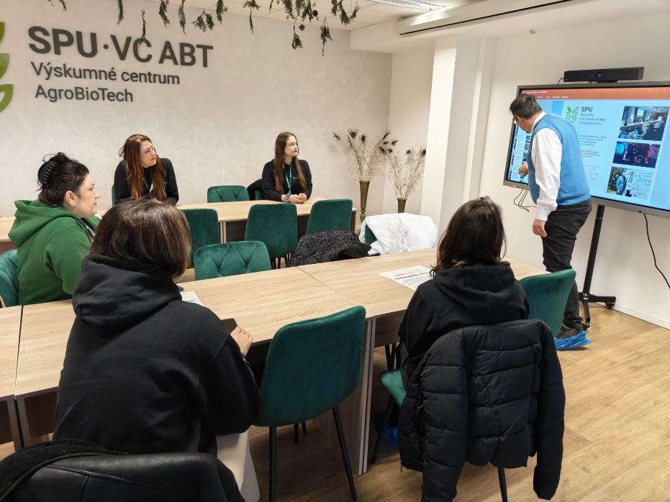

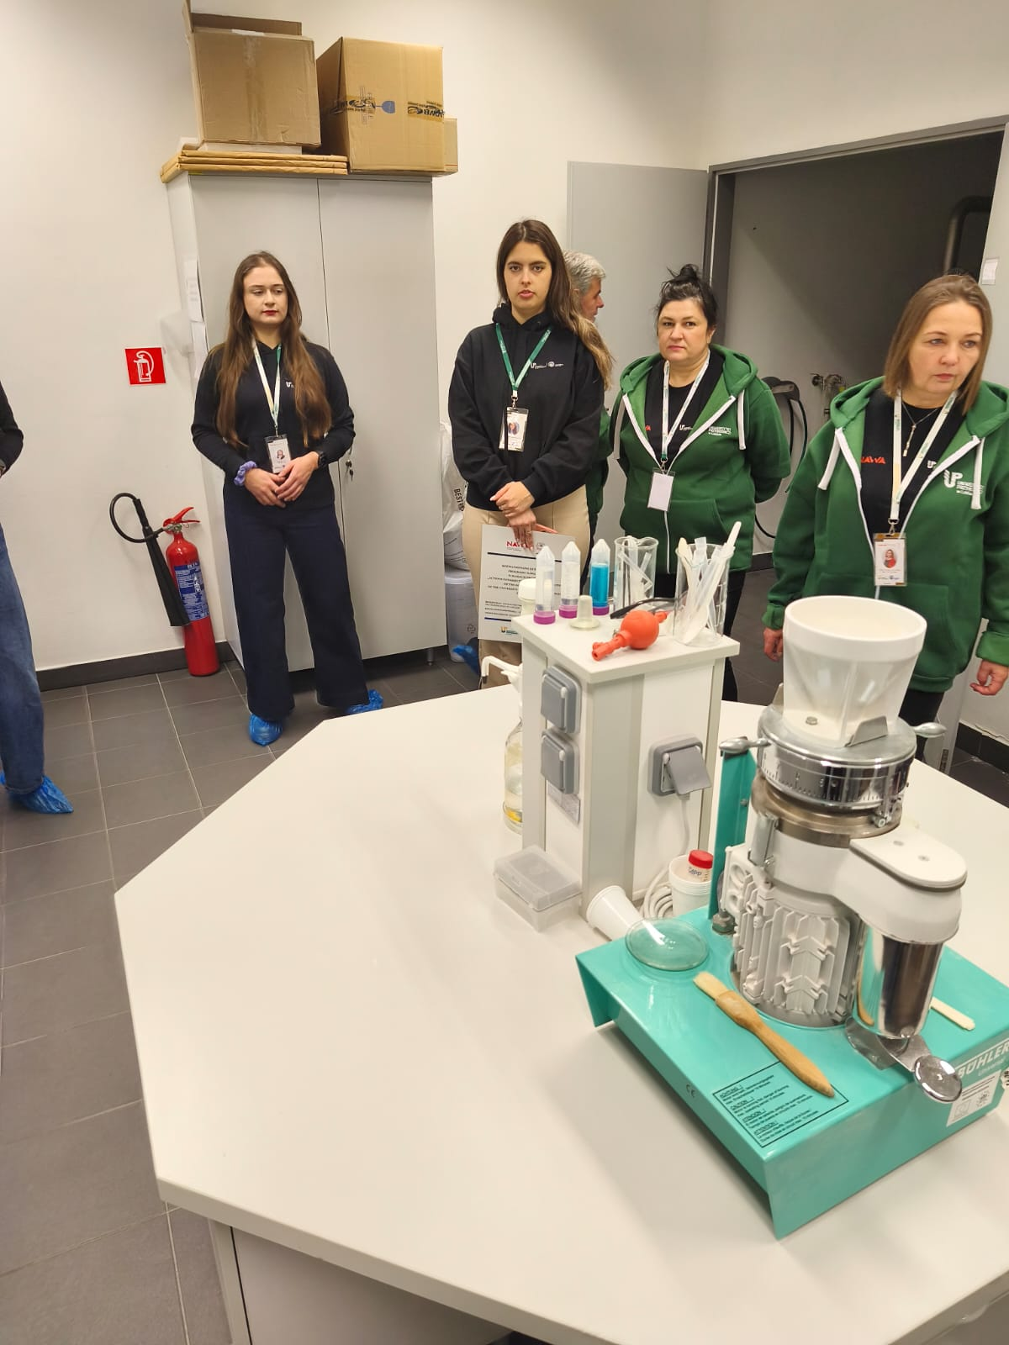
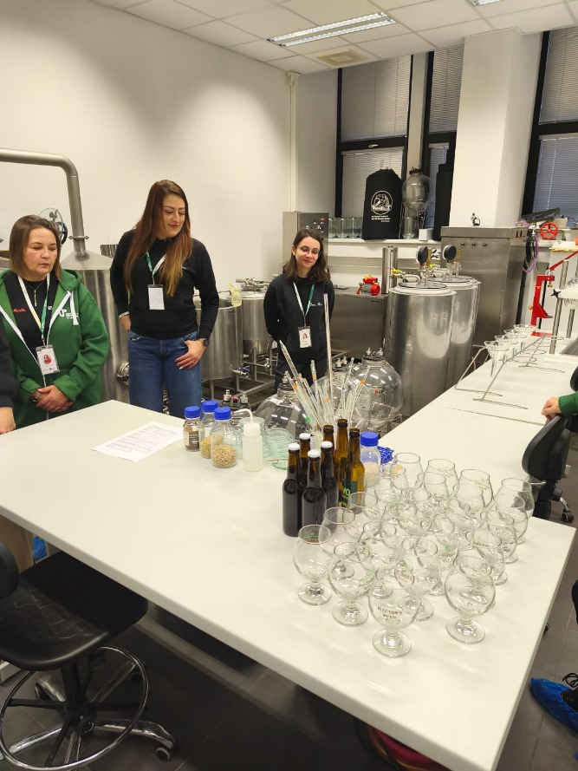
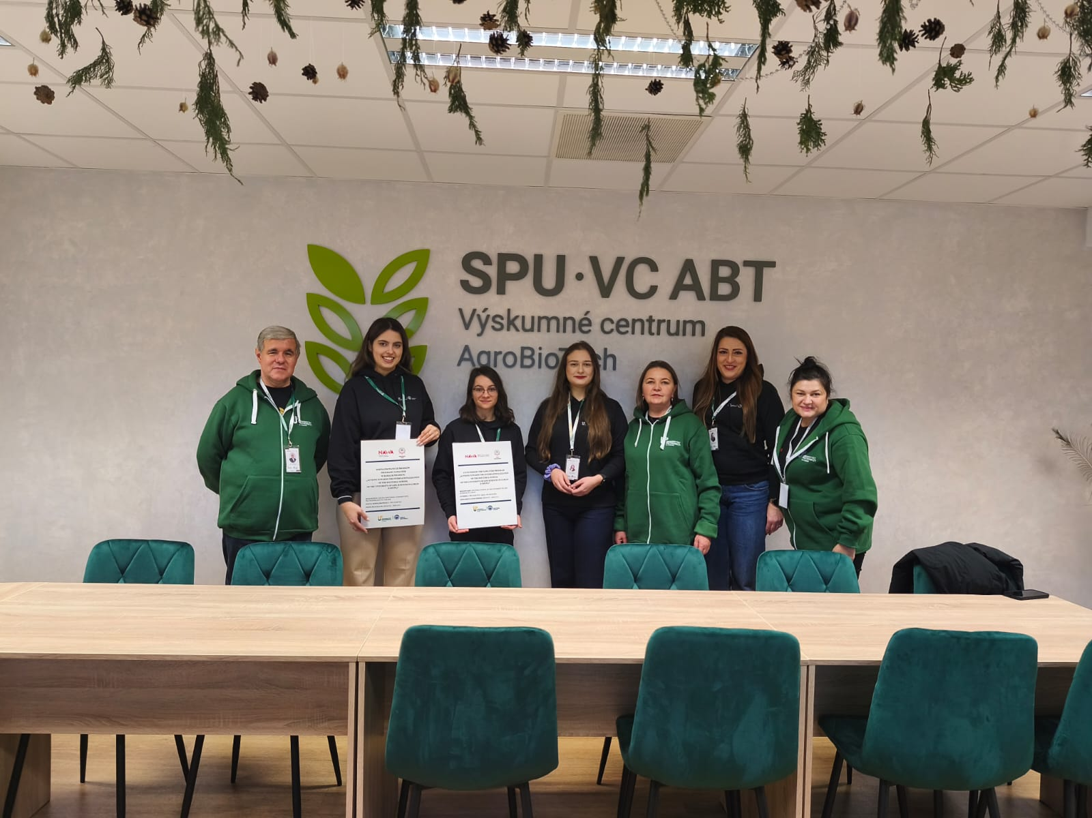

- Getting to know the history of Nitra – sightseeing of the castle and the old town in Nitra.
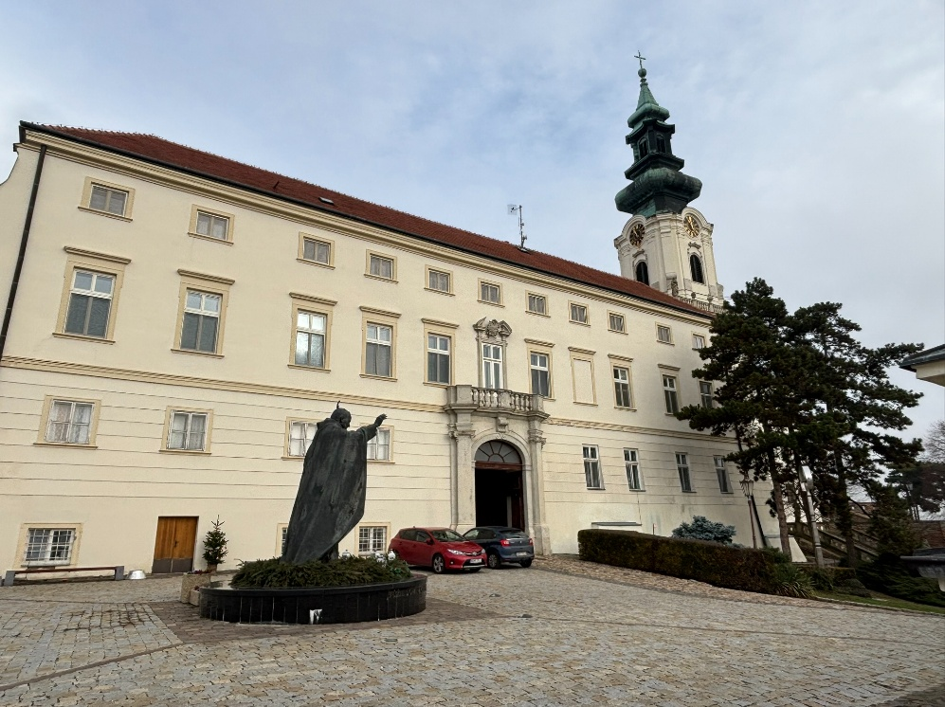
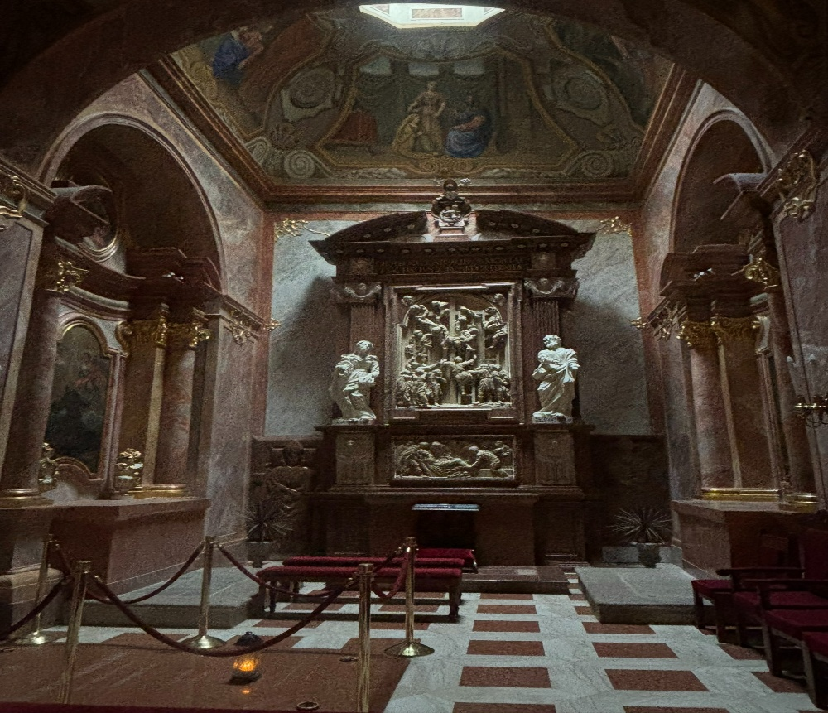
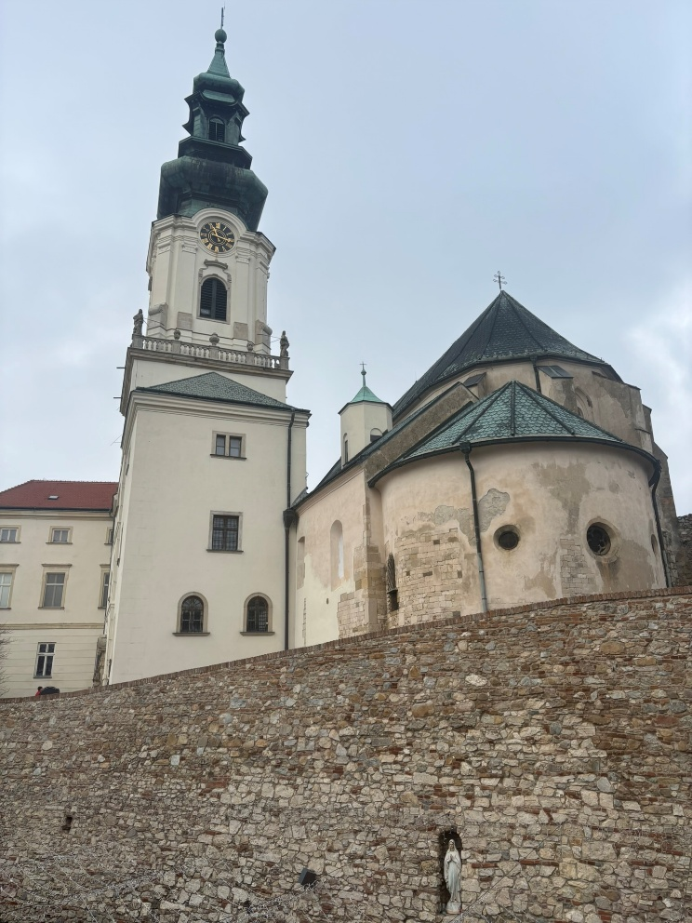
The fourth day of the visit:
- Departure from the hotel in Nitra, return to Lublin.
Visit results:
- Presentation of the educational and research offer of the ULSL Doctoral School,
- Distribution of promotional materials,
- Establishing possibilities for exchange of PhD students, researchers, and joint research projects,
- Identification of areas for joint research projects and supervisor cooperation,
- Establishing contacts that may lead to future research collaboration,
- Familiarization with the curriculum, teaching structure, and research infrastructure of the Slovak University of Agriculture in Nitra,
- Assessment of possibilities for conducting foreign research internships for PhD students.

This project was funded by the National Agency for Academic Exchange (NAWA) under the STER program: "Actions towards the internationalization of the Doctoral School of the University of Life Sciences in Lublin (I-SDUPL)."

