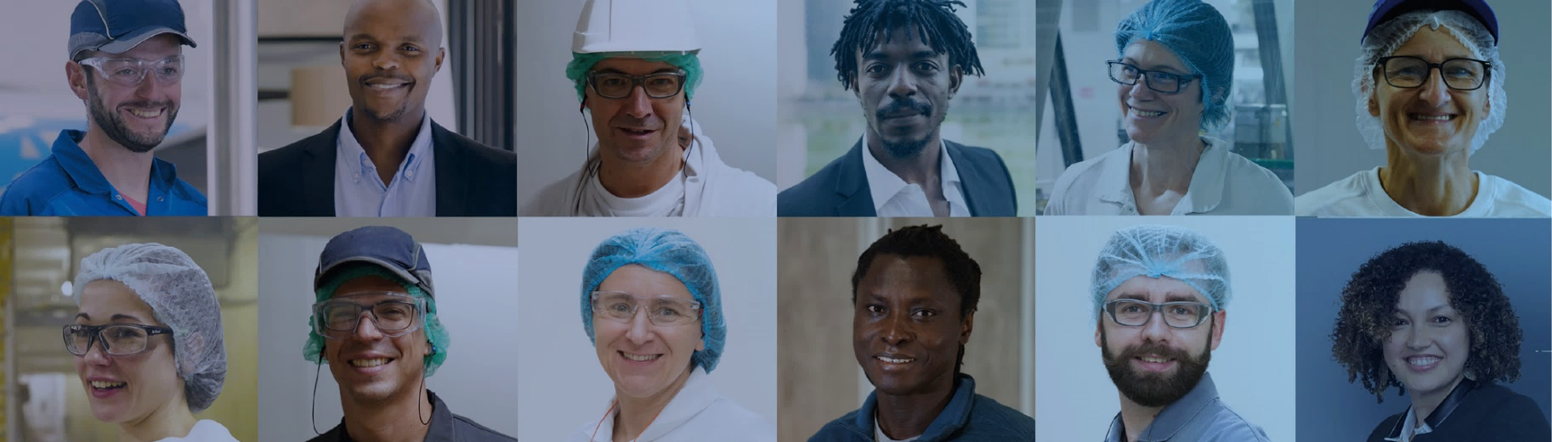
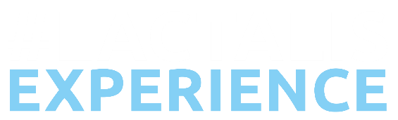
STORY, PASSION, EXPERTISE

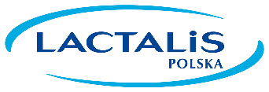
From your STORY to ours.
Lactalis Group is known the most by its products, well-known under President and Galbani brands. High quality and excellent taste is our fundamental promise.
Would you like to develop your career in food industry within an international company?
Are you open to learn a new language and to take interesting challenge? This offer is for you!

From your PASSION to ours.

Company-Sponsored Training Programme to work
in Milk Collection or Production Plant in Poland
(the place of training: FRANCE)
(destianation place for job: POLAND)
The programme is managed by a major Grande Ecole in the field of Life Sciences in France - L’Ecole Supérieure des Agricultures (ESA).
SUCCESSFUL CANDIDATES WILL:
- get the passionate work in Lactalis Group Milk Collection or Production Plant in Poland after program completion;
- spend two years in France – with an additional 6 months of intensive French language training (advanced level);
- receive high level training in technical and management competencies;
- have full expenses covered (travel, tuition, insurance etc.);
- get a job contract as an apprentice (trainee) and a salary while stayng in France of approx. 1000€ per month (depends on age at terms of contract);
- get an equivalent of an MSc2 degree of French Grande Ecole.
REQUIREMENTS:
Candidates must have:
- a Master’s degree or Bachelor’s in a Life Science such as:
- Milk Collection: Food Technology, Dairy Technology, Animal Science;
- Production: Food Technology, Dairy Technology;
- an advanced level of English – min. B2;
- a strong motivation to develop a future career in industry in Milk Collection or Production Site in international Group;
- a desire to learn new cultures and a new language – please note: no French required to apply;
- a motivation to take part in an interational program and willingness to return home.
The candidate must be under 28 years old in September 2025 to apply.
Please send your CV: rekrutacja@pl.lactalis.com and complete your application on the university website:
https://www.groupe-esa.com/en/training-offers/

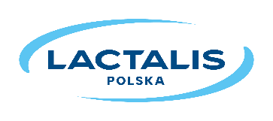
From your EXPERTISE to ours.
DISCOVER OUR OPPORTUNITIES | FOLLOW US ON
85.500 EMPLOYEES| 90 COUNTRIES | NO. 1 DAIRY GROUP IN THE WORLD

