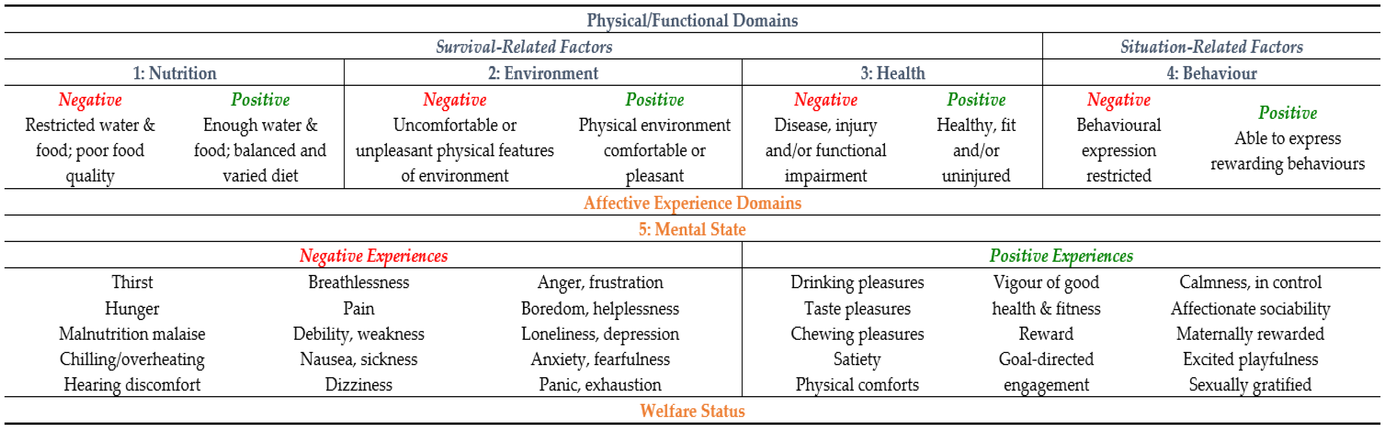
Not acceptable -
Acceptable +
Positive 2+
Good 3+
Very Good 4+
Perfect 5+

Source: Mellor et al. 2016

